AWS CHALLENGE

1. Launch one **EC2 instance** using **Amazon Linux 2**.

*log into aws console ,

*launch an linux instance

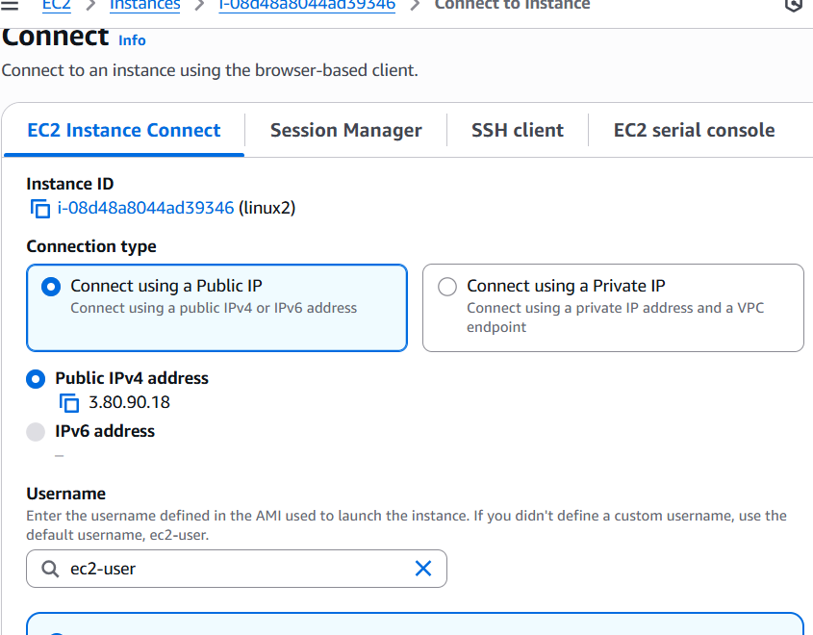

*open gitbash and connect to instance

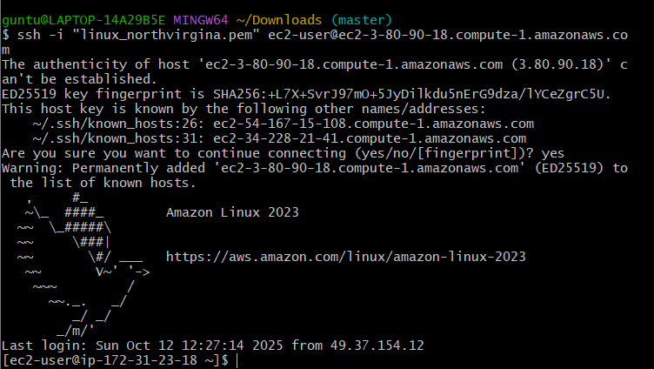

2 . Install Docker.

*install docker

*switch to root user = sudo su

*sudo yum install docker

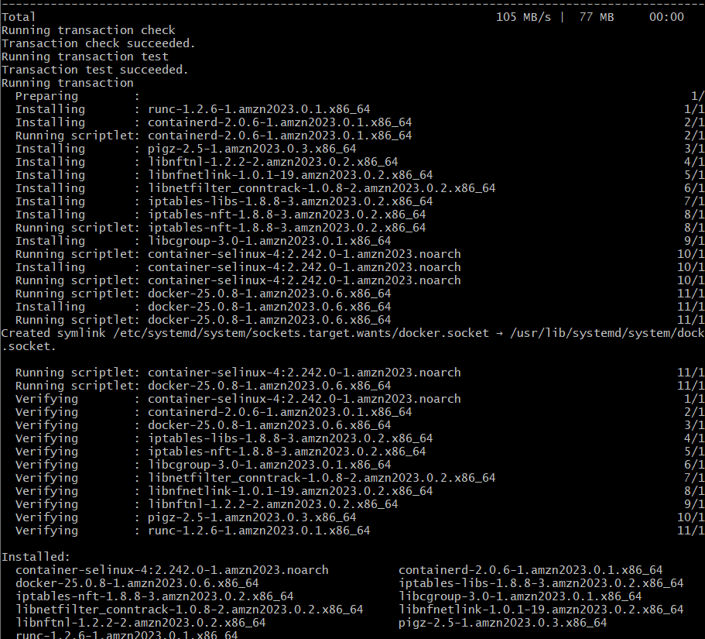

3 . install Jenkins

*sudo update

*to install Jenkins

sudo dnf update -y

sudo dnf install java-17-amazon-corretto -y

*to verify java -version

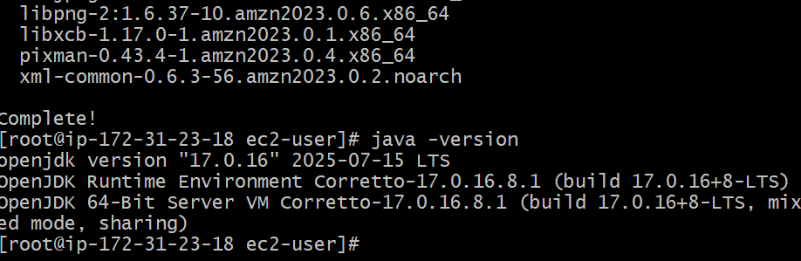

*add Jenkins repository

sudo wget -O /etc/yum.repos.d/jenkins.repo \

https://pkg.jenkins.io/redhat-stable/jenkins.repo

sudo rpm --import <https://pkg.jenkins.io/redhat-stable/jenkins.io-2023.key>

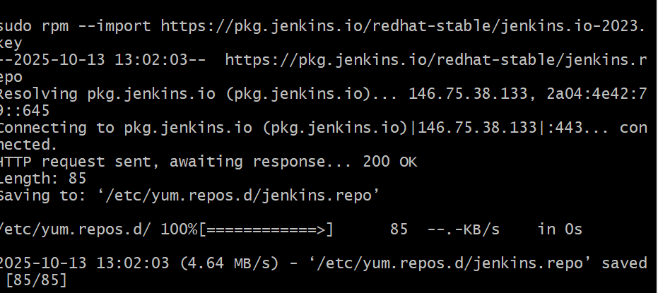

*install Jenkins

sudo dnf install jenkins -y

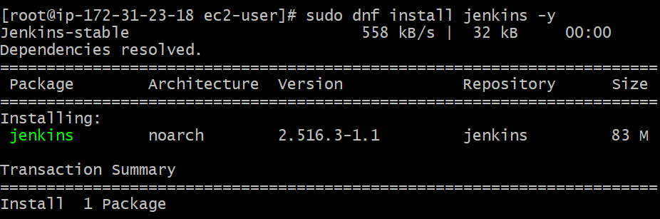

*sudo systemctl enable Jenkins

Sudo systemctl start Jenkins

Sudo systemctl status Jenkins

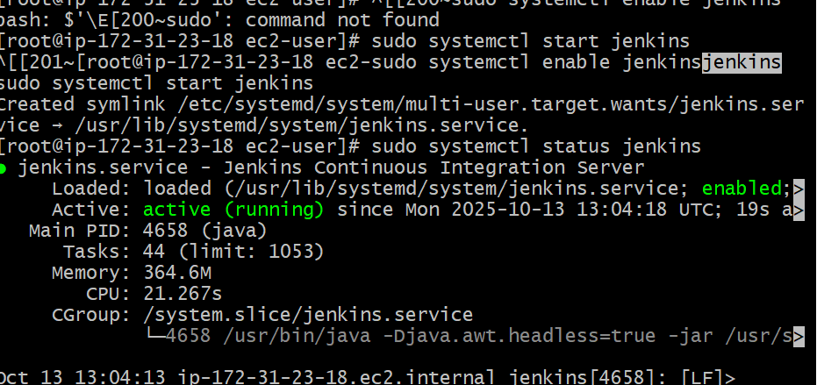

Install Apache.

*sudo yum install httpd

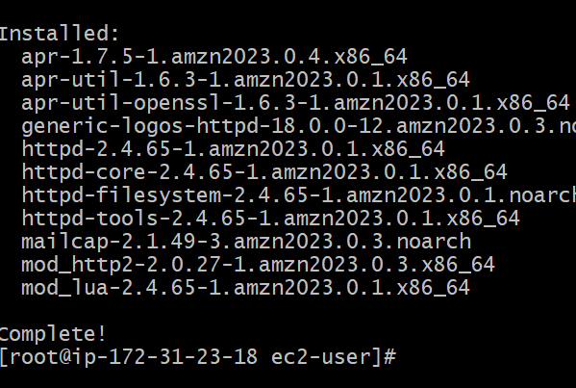

Install nginx

*sudo yum install nginx

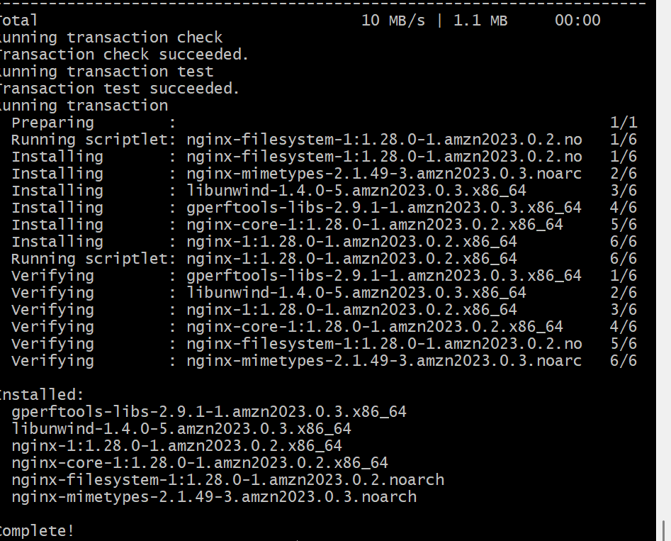

Install Apache Tomcat.

*first install java

sudo dnf install java-17-amazon-corretto -y

*cd /opt

sudo wget <https://archive.apache.org/dist/tomcat/tomcat-10/v10.1.48/bin/apache-tomcat-10.1.48.tar.gz>

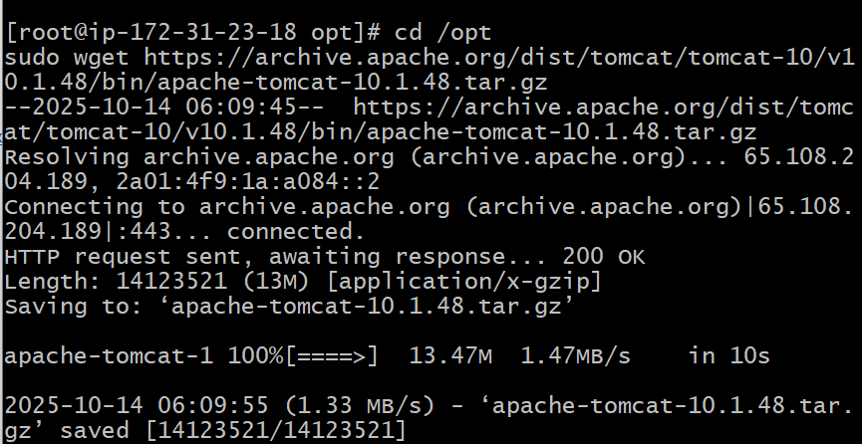

*go to location

cd /opt/tomcat/bin

*now enter ./ startup .sh

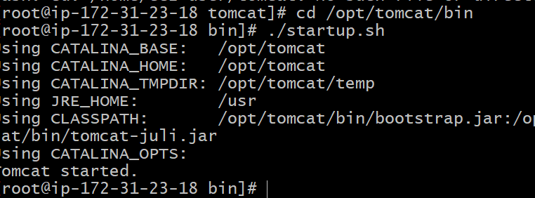

Started

